REQUEST FOR PROPOSALS TO PURCHASE RECREATIONAL LAND ALONG SPRING CREEK, TOWN OF BURNETT, DODGE COUNTY, WISCONSIN

**DISCLAIMER: NO STATEMENTS IN THIS REQUEST ARE BINDING REPRESENTATIONS AS TO THE CONDITION OF THE PROPERTY INVOLVED OR ANY TERMS OF A SALE. THIS DOCUMENT IS NOT AN OFFER TO SELL. A CONTRACT FOR SALE MUST BE MADE THROUGH A FORMAL WRITTEN OFFER IN AN ACCEPTABLE FORM.**

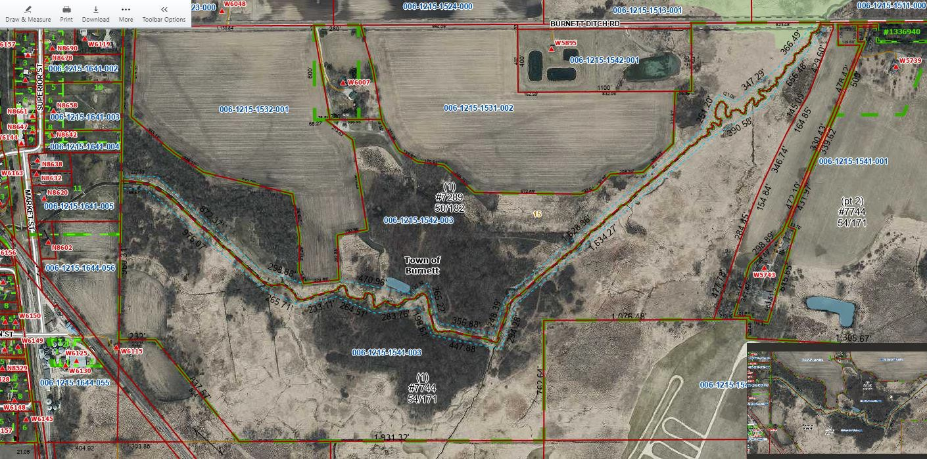

**Screenshot of the Dodge County GIS site showing the Property.**

**Photo showing one section of the Creek.**

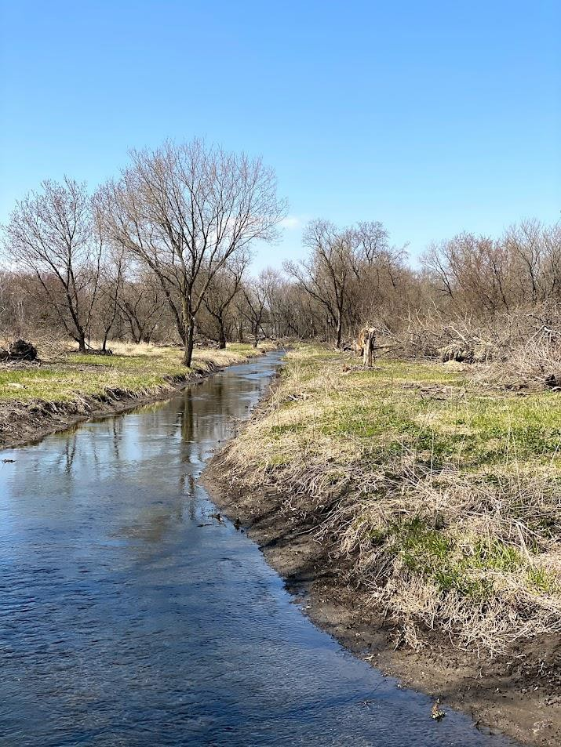The Town of Burnett is interested in selling 80 acres (more or less) of beautiful recreational land with more than a mile of frontage on the Spring Creek. That Creek is a clear spring-fed stream running into the Horicon Marsh. The Town purchased the land to clear debris in the stream and enhance the Creek’s ability to carry storm water downstream. While this property is not suitable for residential development, it would provide a wonderful place to hike, camp, fish and hunt or to engage in other outdoor recreation.

The following are the major terms and conditions which apply to the Town’s request for proposals.

The real estate involved is part of Lot 1 of Certified Survey Map 7744, herein called the “Property.” A copy of the CSM is attached. The survey is not guaranteed by the Town; purchasers are welcome to have their own survey performed. The Property to be sold will be 80 acres, more or less. Note that the area includes 5.948 acres of meander area of the Creek.

The Property includes large areas that are in Flood Zone X and A and are mapped as such. There is also a large area of wetlands. The land is predominantly marshy, has many trees, marsh vegetation and brush.

Legal Access to the Property is from Burnett Ditch Road. There is a 114.27 foot length where the Property abuts Burnett Ditch Road. The terrain at that location is sloped. The access is mostly within the meander line of the Creek. It is possible to access the Property, but not to build a road which meets public road standards.

The real estate will be sold subject to an easement in favor of the Town of Burnett which allows the Town to access the property to remove materials from the Creek or the streambank which are impeding the flow of water downstream. That access would be exercised according to the terms of

the easement, which will be finalized with agreement of the Buyer. The purpose of the easement is flood prevention.

The previous statements are made on the basis of information provided to the Town which is reasonably believed to be accurate. All offerors are responsible for undertaking their own investigation of site conditions and circumstances. The Town does not warranty any conditions of the Property except that the Town has merchantable title.

Other specific terms of this Request are:

1. Any sale of the Property is contingent upon approval of the sale by the Town Meeting, if required.
2. The sale of the Property is subject to a right of first refusal held by Matthew L. McDowell, Brant

M. McDowell and Brady M. McDowell.

1. If the property is purchased by a public or tax exempt agency, the sale will be contingent upon an agreement to pay the same property taxes on the land which would be due were the land still taxable, indefinitely.
2. The Town reserves the right to sell the Property, in whole or in part, as may be most advantageous to the Town. The Town will review proposals to separate lots from the property. The Town cannot assure or guarantee that any development of any lands would be approved by the Town. Offerors are on notice that the Town and Dodge County have zoning authority over the Property and may exercise that authority in the future.
3. The Town reserves the right to reject any or all proposals for purchase and sale, in the sole discretion of the Town.
4. The Town directs that information concerning the Property be sent to real estate brokers, agents, interested individuals and public agencies. The notice shall request any person interested in purchasing the Property to provide a proposal to the Town, **to be received** no later than February 21, 2025 at 4:00 p.m. **The proposal and ten copies are** to be sent to the Clerk at W6273 Park Drive, Burnett, WI 53922. **In addition to the paper proposal**, Digital copies of the proposal may be sent to the Clerk at [clerk@townofburnett.wi.gov](mailto:clerk@townofburnett.wi.gov) .
5. The Town reserves the right to negotiate terms of a purchase with a single or multiple interested parties.
6. The Town will be represented in the sale by its officials and legal counsel. The Town will not enter into a seller’s listing agreement but will pay a commission as agreed.
7. Closing will be scheduled upon agreement on terms and approval of the Town Meeting, if required.
8. No proposal will be considered unless it is accompanied by either (a) proof that the offeror has the funds to close the purchase as of the date the proposal is made or (b) a commitment letter from a financial institution stating that the financial institution commits to provide the offeror with purchase money financing.

THIS REQUEST FOR PROPOSALS MAY BE WITHDRAWN OR MODIFIED AT ANY TIME WITHOUT NOTICE.

THE TOWN OF BURNETT RESERVES THE RIGHT TO REJECT ANY AND ALL PROPOSALS.

BUYER IS RESPONSIBLE FOR VERIFYING ALL MATERIAL FACTS PERTAINING TO THE PROPERTY.